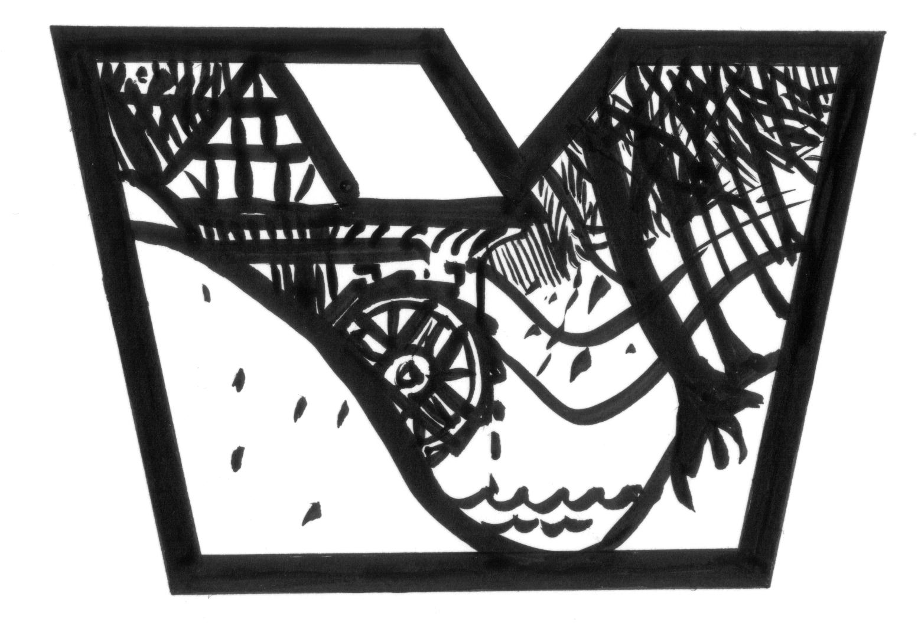
Some facts about the Local Historical Society for Vintersbølle/Nyråd:
Lokalhistorisk Forening
for Vintersbølle/Nyråd
Møllevej 4A – 4760 Vordingborg Tlf. 51 68 29 82
E-mail adr.: nyraad@vinterhistorie.dk
www.vinterhistorie.dk

- The society works to preserve Beværterhuset.
- The society collects a lot of pictures and knowledge about Vintersbølle and Nyråd.
- The society works to ensure that in future our children can obtain knowledge about the neighbourhood.
- The society arranges ‘green tours’.
- The society has adopted the burial mound with the Valdemar stone and arranges to keep and preserve the mound.
- The society arranges trips to museums, talks etc.
- The society cooperates with the museums in Køng and the South Zealand Museum, Vintersbølle School, and the other societies in Nyråd, the county of Zealand and the press.
- All interested are welcome to attend our meetings on the last Monday of the month at 7 p.m. at Vintersbølle School – donۥt hesitate to bring your neighbour.
- The members receive a newsletter twice a year.
Contact on bleaching:

Member of the board
Karen Schou-Pedersen Tlf.: 29 89 67 27
Gunhild Mathisson Tlf.: 55 37 33 02

Some notes on bleaching:

Bleaching is a series of processes to decolorize organic materials, especially textiles, which in their natural state are often yellowish/brownish.

Bleaching used to take place in the following way:

Initially the linen was washed in lye made from ashes from trees and plants, as the ashes contained sulphates, carbonates, chlorides, phosphates, and other materials, which have a bleaching effect.

The linen was placed in a vessel and over the vessel a piece of cloth was stretched out. Fine clean ashes – beech ash was the best – were placed on the cloth.

After that boiling water was poured over the ashes so that the water was filtered down over the linen. The water was drawn off and poured through the ash cloth again. This process was repeated many times.

Then the linen was beaten well. The peasants used a batler, but the bleacheries used a washing machine with a vessel and two hammers worked by the wheel of a water mill.

Later on e.g. at the Vintersbølle Bleach Field a stamp machine was used for the aftercare of the linen.

The linen was then hung up to drip in drying towers and when it had finished dripping the linen was put out to bleach on a grass field or slope. The bleach field was always on an open place – preferably with a wood on both sides and by the sea. The fresh sea air could then with the help of the wind keep the humidity and the sunlight, which was reflected from the sea made the bleaching efficient.

At the edge of the piece of linen there were a number of straps through which small wooden pegs were put so that the wind could not make the piece roll. The linen had to lie on the bleach field for a long time and a watch was kept so that the linen did not have to be taken in at night and was not stolen.
If rain was not to be expected the linen had to be spattered.
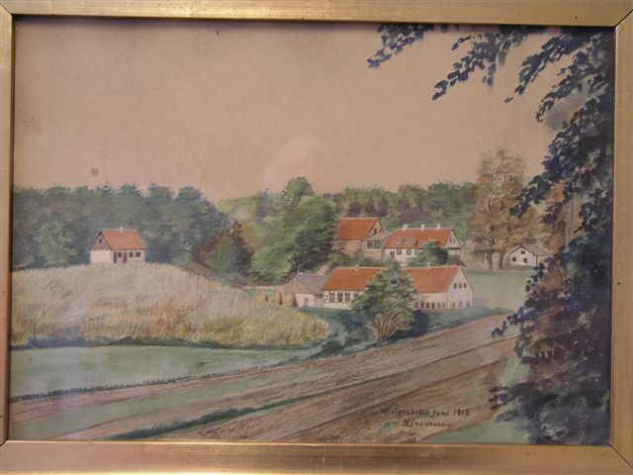
The painting is from June 1912.

Vintersbølle Bleach Field:

The water mills in Vintersbølle Wood formed the foundation for the establishment of a bleachery to the Køng Linen Works in about 1795-1800. Many competent ٔguest workers from e.g. Germany, England, and Scotland and among them many weavers came to the Køng Linen Works.

Charles Burd came from Scotland and became bleaching master at the Vintersbølle Bleach Field about 1800. At the census on 1st February 1801 Charles Burd is mentioned as bleaching master at the bleach field under The Ryberg Works.

In 1851 the Køng Linen Works moved the whole production to Vintersbølle Bleach Field. In 1906 the linen works closed down. Today the bleach field at Vintersbølle is enclosed with a fence and cattle graze there during the summer.

